

Jose Rizal Memorial State University
Gov. Guading Adaza St., Sta. Cruz,
Dapitan City, Philippines

GSU Gateway User Manual
By:
Bryan Bantilan
Patrick Joshua Nicolas
Edrean Balonga
Bernadette Bantilan
Jenifer Saguindang

May 19, 2025

Account Creation
Purpose: This guide walks new users through the process of creating an account to securely access the system.

Step 1: Go to Login Page
- Open the system login screen.
- Click on “Sign Up” or “Create Account”.
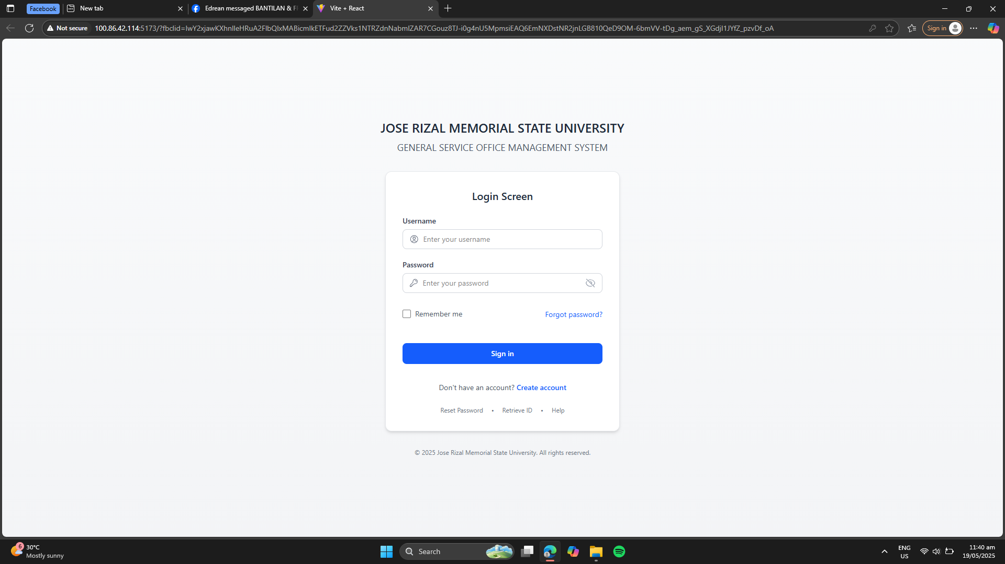

Step 2: Fill Out the Registration Form
- Enter all the required information in the registration form:
  - Full Name
  - Email Address
  - Password
  - Role (e.g., Student, Faculty, Staff)
  - Department or Office
  - Contact Number
- Double-check your details for accuracy.

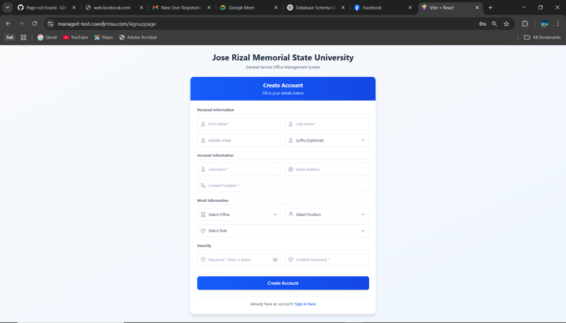
Step 3: Submit the Form
- Click the “Signup” button.
- You will receive a confirmation message:
“Your registration has been submitted and is pending admin approval.”
- You will then be redirected to the Login Page.

Note: Wait for an Admin to review and approve your account. Once approved, you can log in and begin using the system.

Change Password
Purpose: This guide walks new users through the process of changing the password.

Step 1: Go to Login Page
- Open the system login screen.

- Log in your credentials.

Step 2: Go to Profile
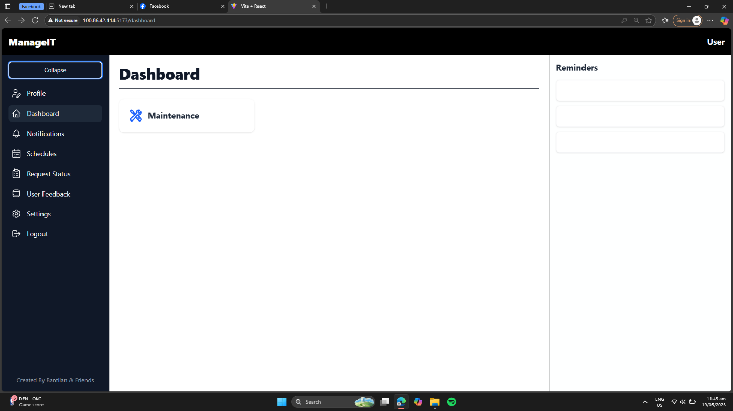

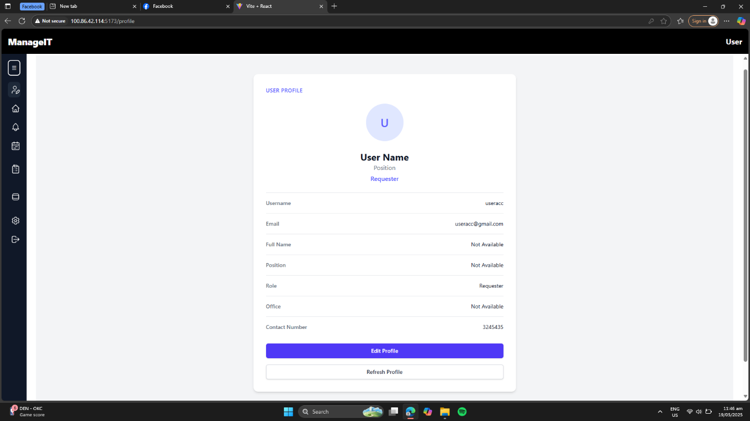
Step 3: Click Edit Profile

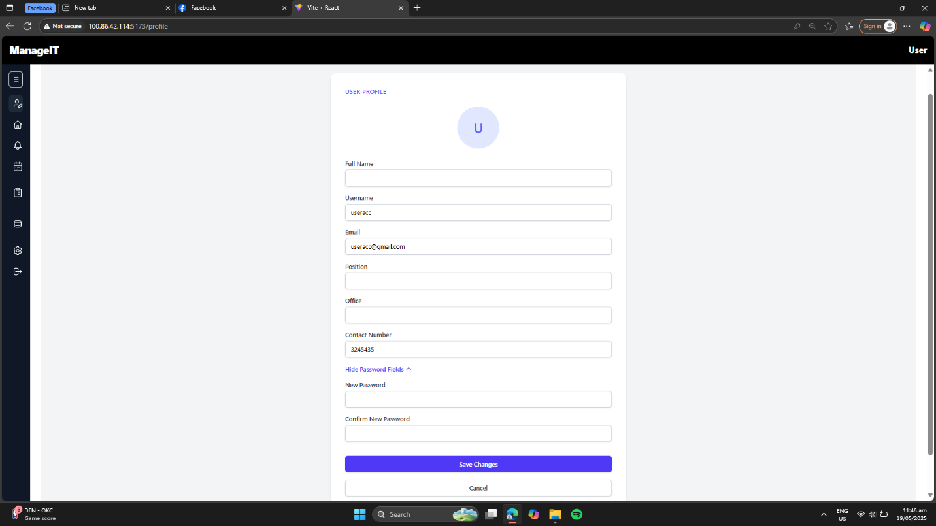
Step 4: Enter New Password and Save Changes

Maintenance Request Submission
Purpose: This guide helps clients or end users submit maintenance service requests for janitorial, carpentry, electrical, or air conditioning issues.

Step 1: Login
- Open the maintenance system platform.
- Log in using your credentials.
  - You can log in as a Requester, Admin, Staff, or Head.


Step 2: Go to Dashboard
- After logging in, you will be directed to your respective Dashboard.
- Click on the “Maintenance” option from the navigation menu.
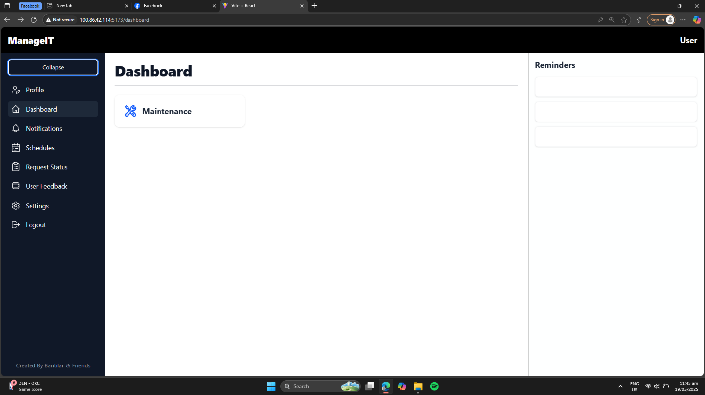

Step 3: Select Maintenance Type
- Choose the appropriate type of maintenance request:
  - Janitorial
  - Carpentry
  - Electrical
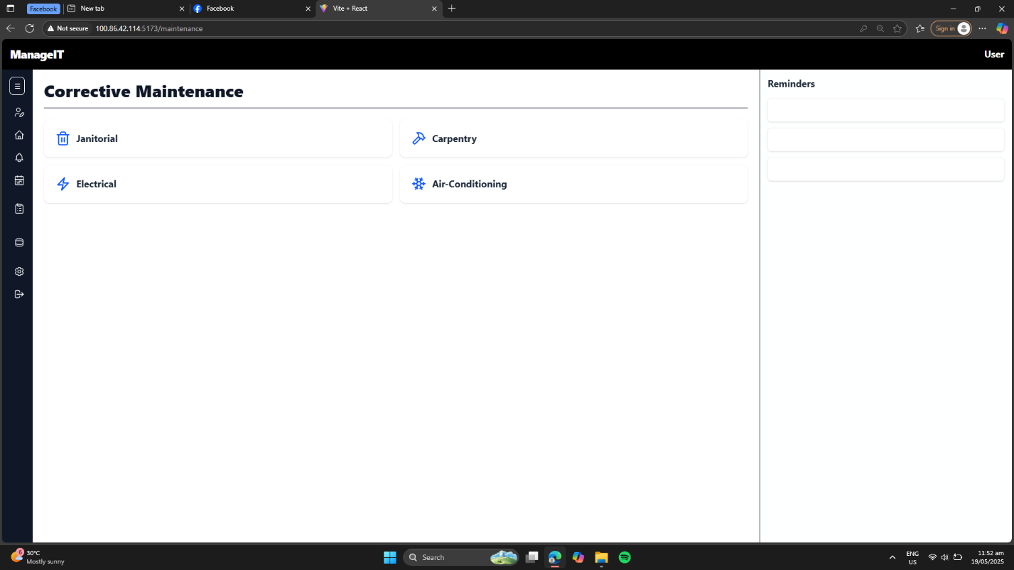
  - Air Conditioning

Step 4: Fill Out the Request Form
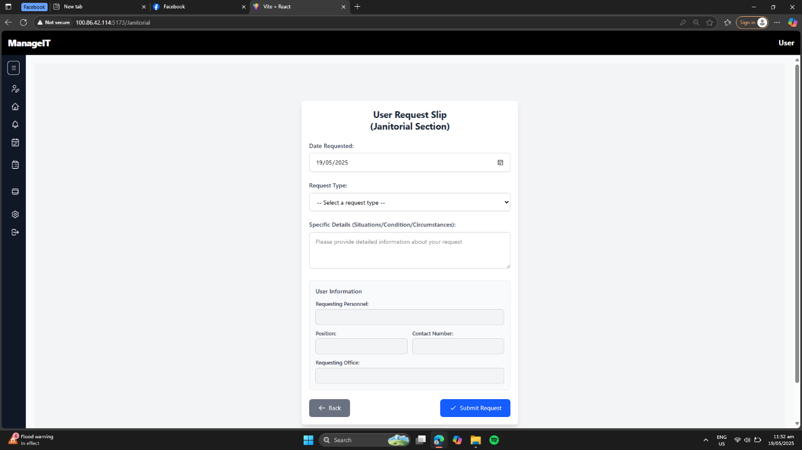
- Complete all required fields.

Step 5: Submit Request
- Review all entries to ensure accuracy.
- Click the “Submit” button to send the request.

Admin-Only Account Approval
Purpose: This guide explains how Admins can review and approve or disapprove new user accounts to control system access.

Step 1: Login as Admin
- Open the system platform.
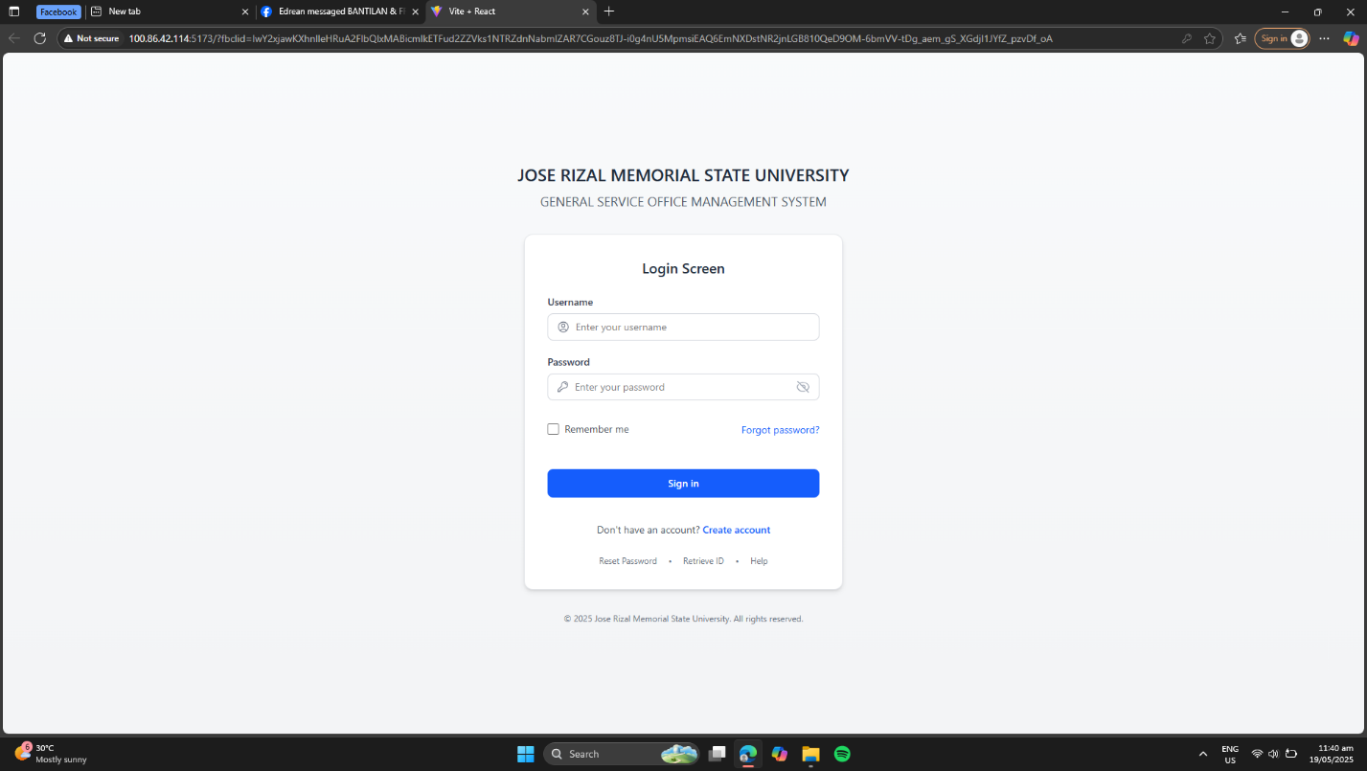
- Enter your Admin credentials to log in.

Step 2: Navigate to Admin Dashboard
- After logging in, you will land on the Admin Dashboard.
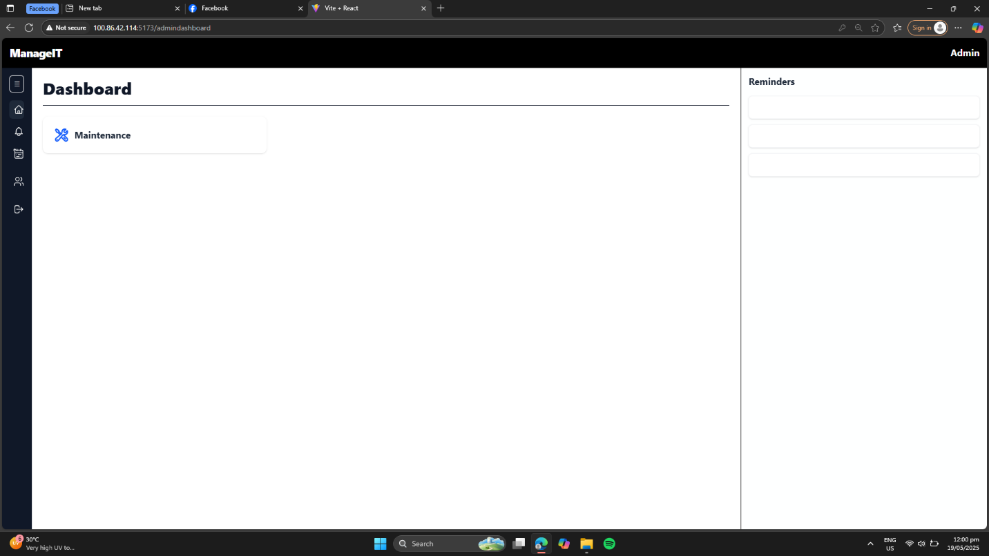
- Locate and click on “User Requests” from the sidebar menu.

Step 3: View Pending Requests
- In the User Requests section, click on the “Pending” tab.
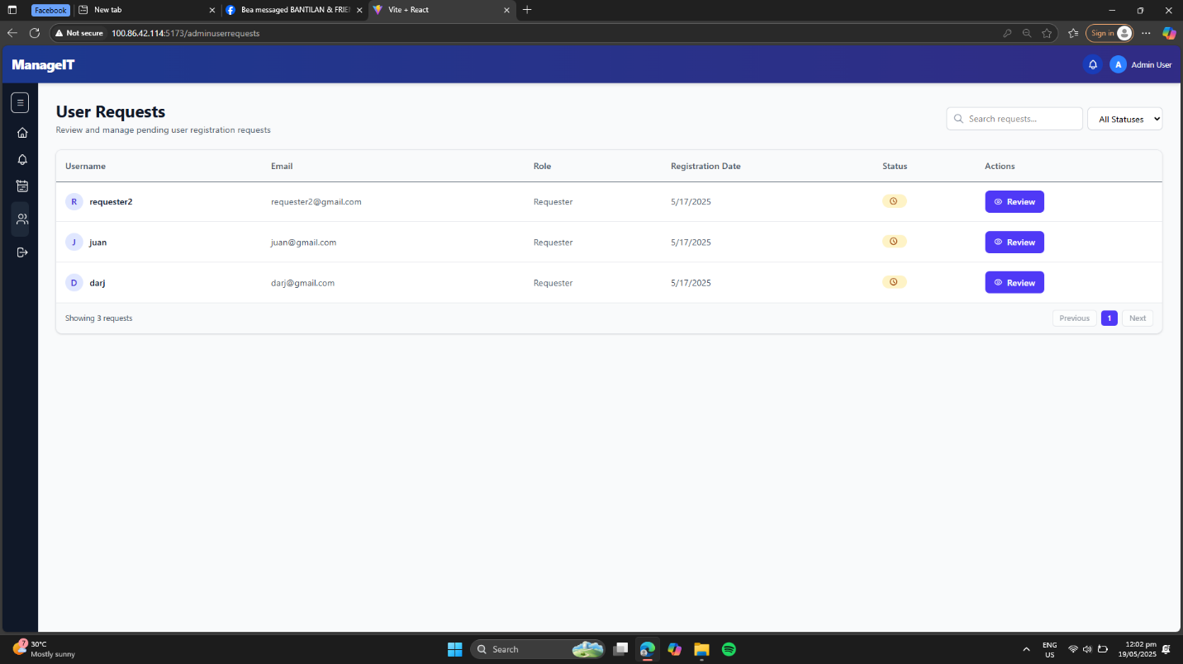
- A list of all new user accounts awaiting approval will be displayed.

Step 4: Review User Details
- Click on any user entry in the pending list.
- Review the full registration information, including:
  - Role (e.g., Staff, Head)
  - Department or College
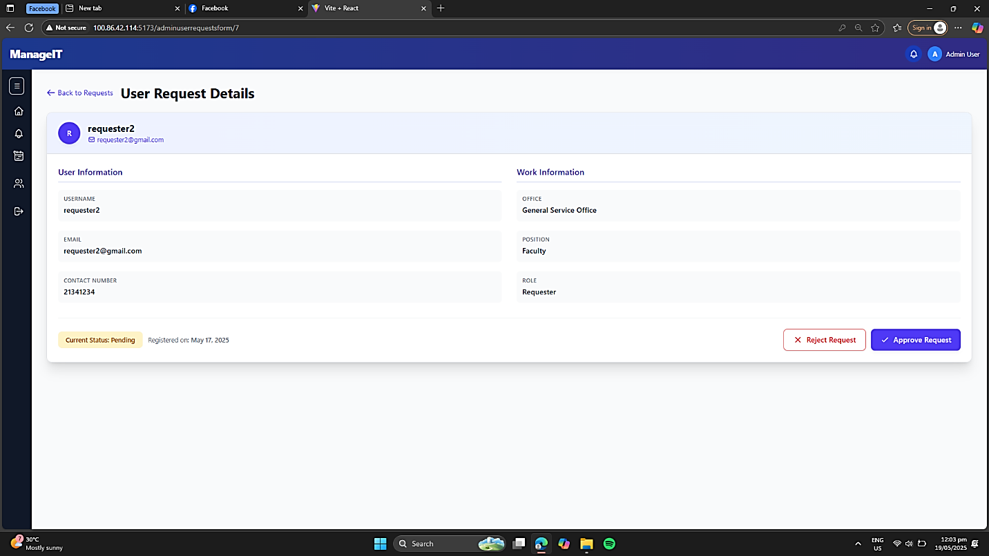
  - Office or Unit

Step 5: Take Action
After reviewing, choose one of the following actions:
Action | Description
Approve | Click this to activate the account and grant access.
Disapprove | Click this to deny access and reject the account request.

Request Approval for Head & Campus Director
Purpose: This guide enables Head and Campus Director users to approve or disapprove maintenance requests submitted by end users.

Step 1: Log In
- Open the system platform.
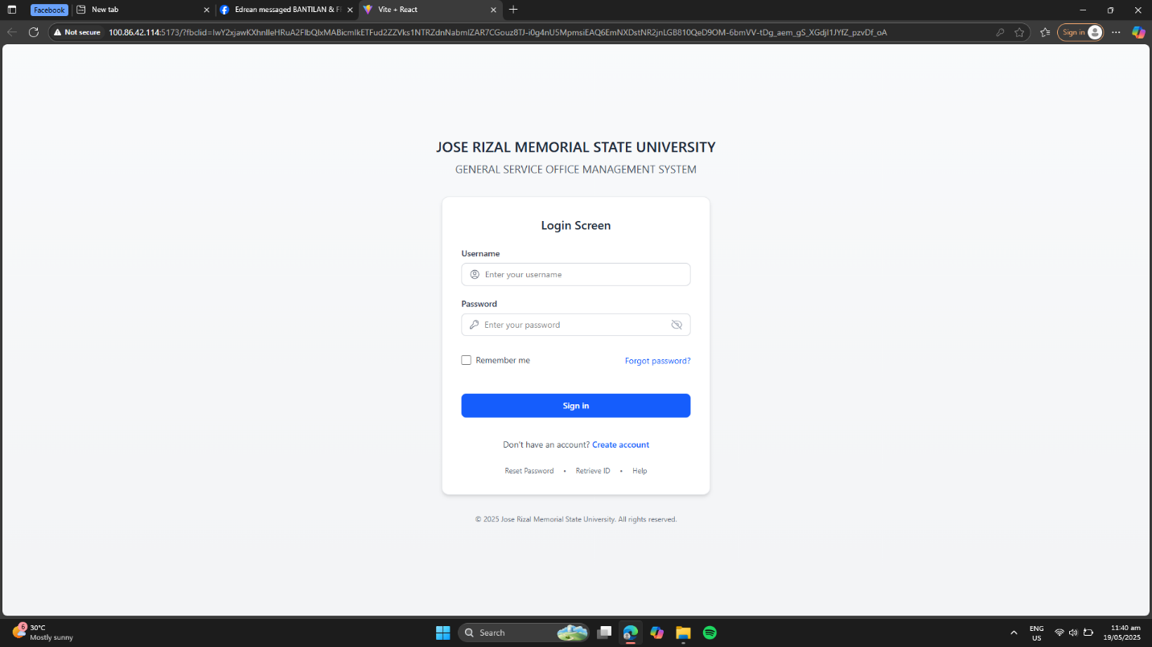
- Use your Head or Campus Director credentials to log in.

Step 2: Access the Dashboard
- After login, you’ll land on the Head/CampusDirector Dashboard.
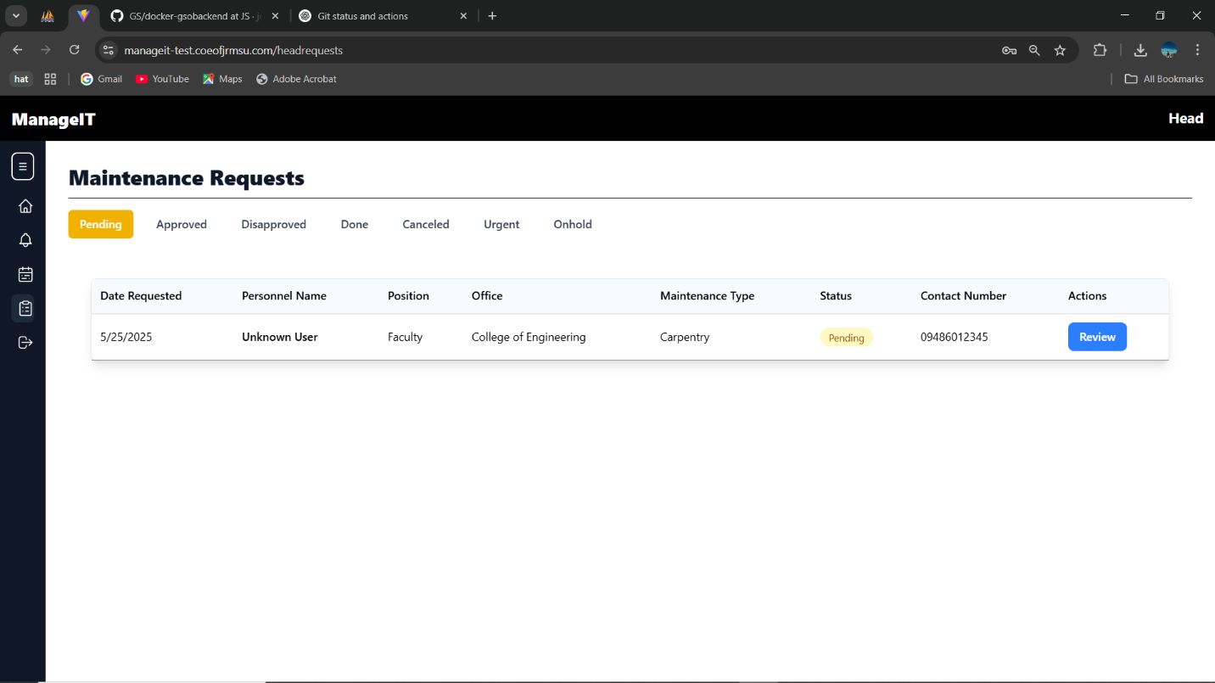
- Navigate to the sidebar and click on “Requests”.

Step 3: Filter Pending Requests
- In the Requests section, apply a filter to view only those with “Pending” status.
- This will show a list of user-submitted requests awaiting your review.

Step 4: View Request Details
- Click the “Review” button beside any pending request.
- The Request Details Page will open, showing:
  - Type of Maintenance (e.g., Janitorial, Electrical)
  - Issue Description
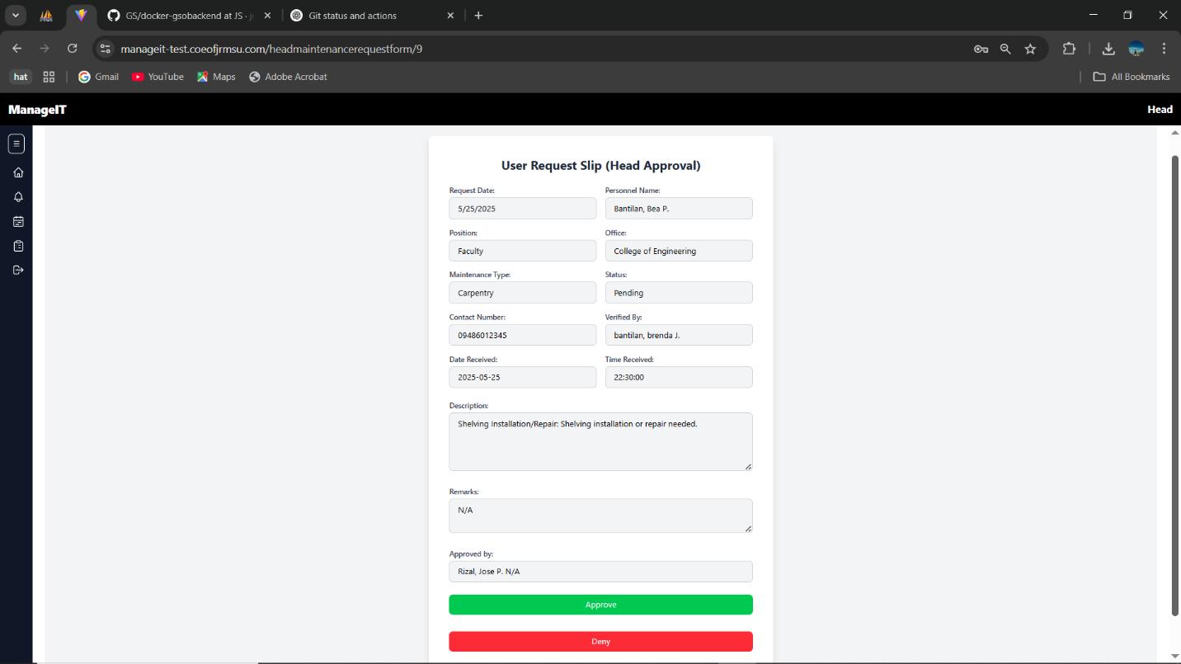
  - Requesting User’s Information

Step 5: Take Action
After reviewing the request, choose from the following action:
Action | Description
Approve | Accept and allow the request to proceed.
Disapprove | Reject the request. You may be prompted to enter a short comment or reason for disapproval.

Viewing Pending Requests (Office Staff)
Purpose: This guide allows Office Staff to view all pending user requests, helping office heads stay informed and manage workload.

Step 1: Log In Using Staff Credentials
- Open the system platform.
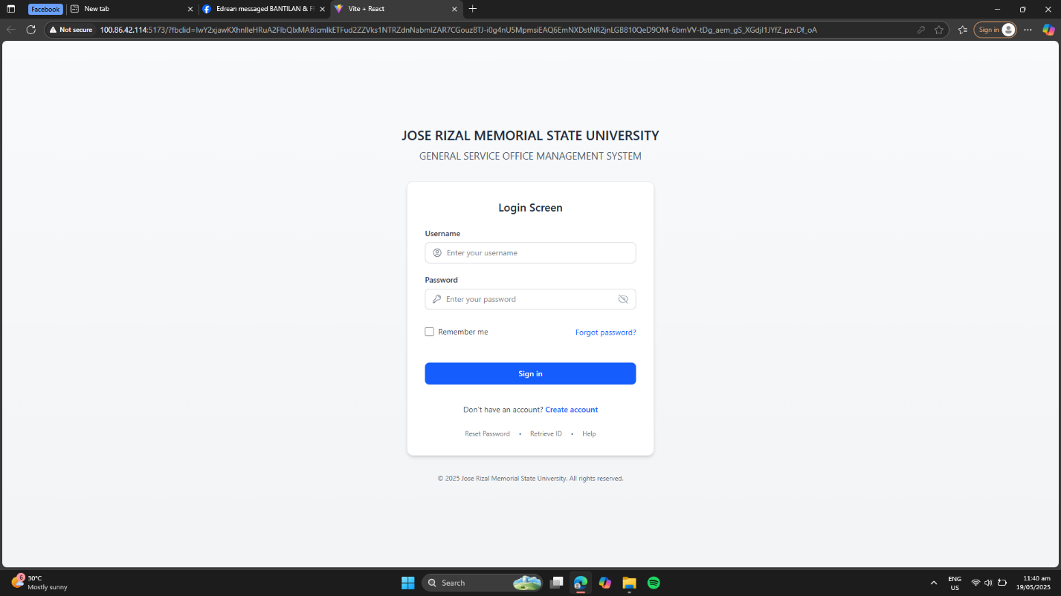
- Enter your assigned Office Staff credentials to log in.

Step 2: Access the Staff Dashboard
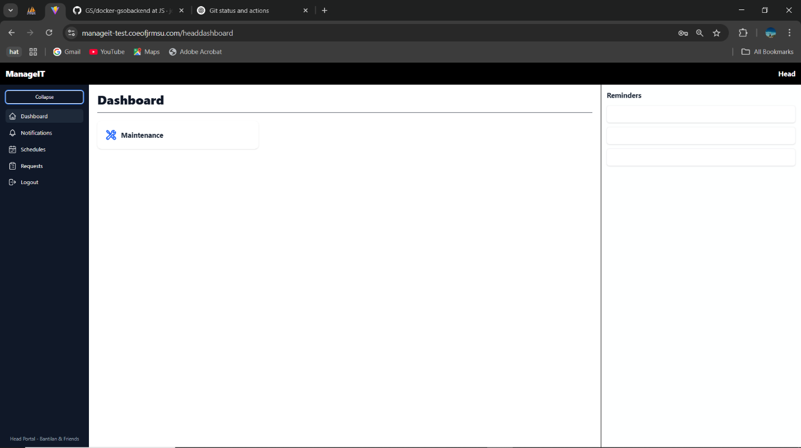
After successful login, you will be redirected to the Staff Dashboard.

Step 3: Navigate to “User Requests”
- On the sidebar, click on “User Requests”.
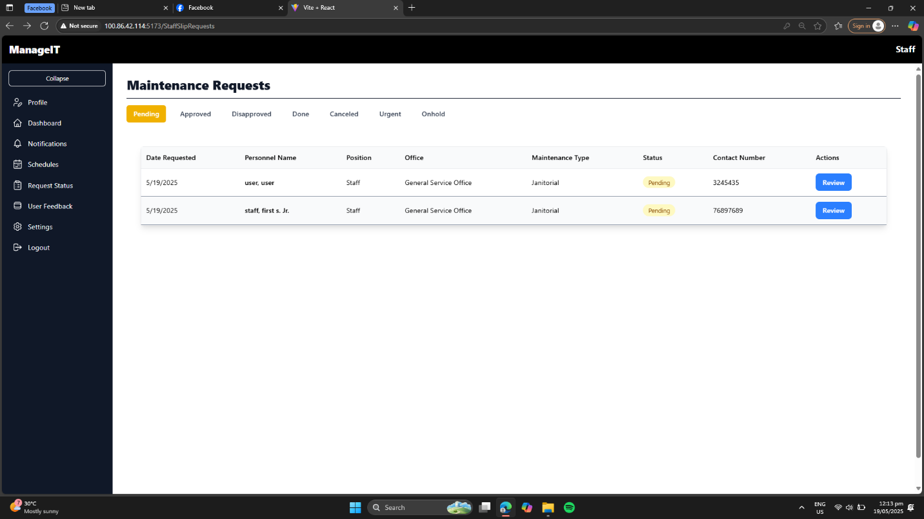
- This section displays a list of all user-submitted requests.

Step 4: Browse the List of Pending Requests
- The list will automatically show pending requests
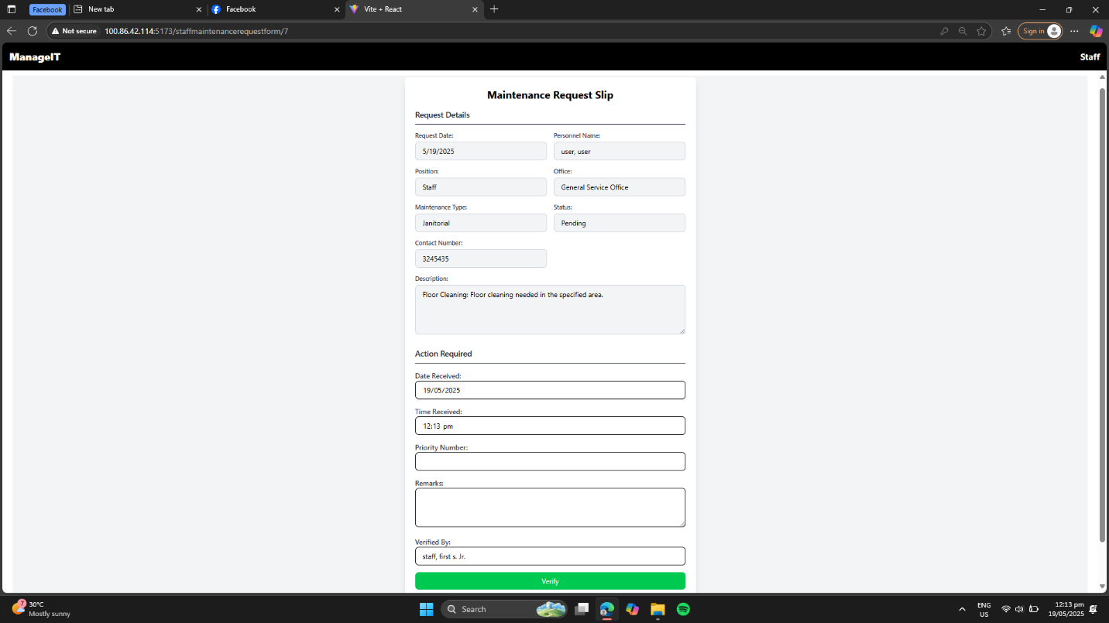
- You can scroll through and monitor the request details (e.g., request type, requestor name, submission date).

Note: Office Staff can view pending requests but cannot take approval actions.
Report GSU Email as Not Spam
- Open email application or website.
- Log in the email used in GSU Gateway System.
- Click More at the left side.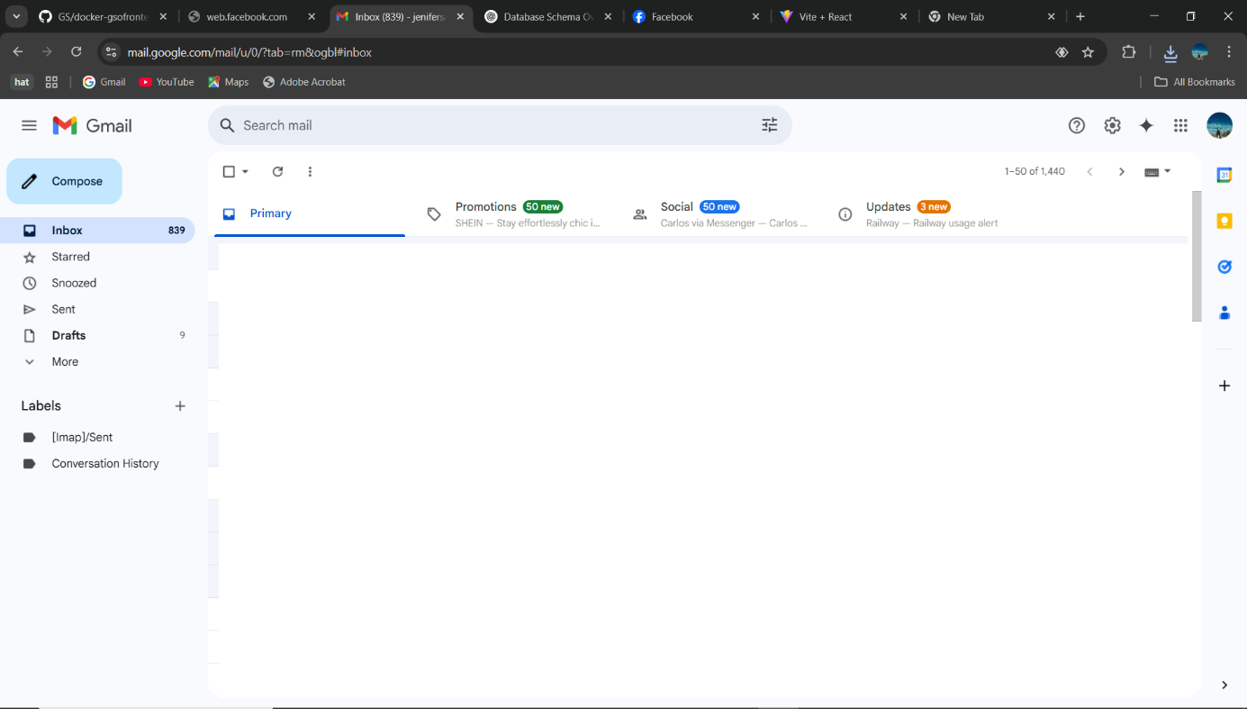
- Then click the label Spam. 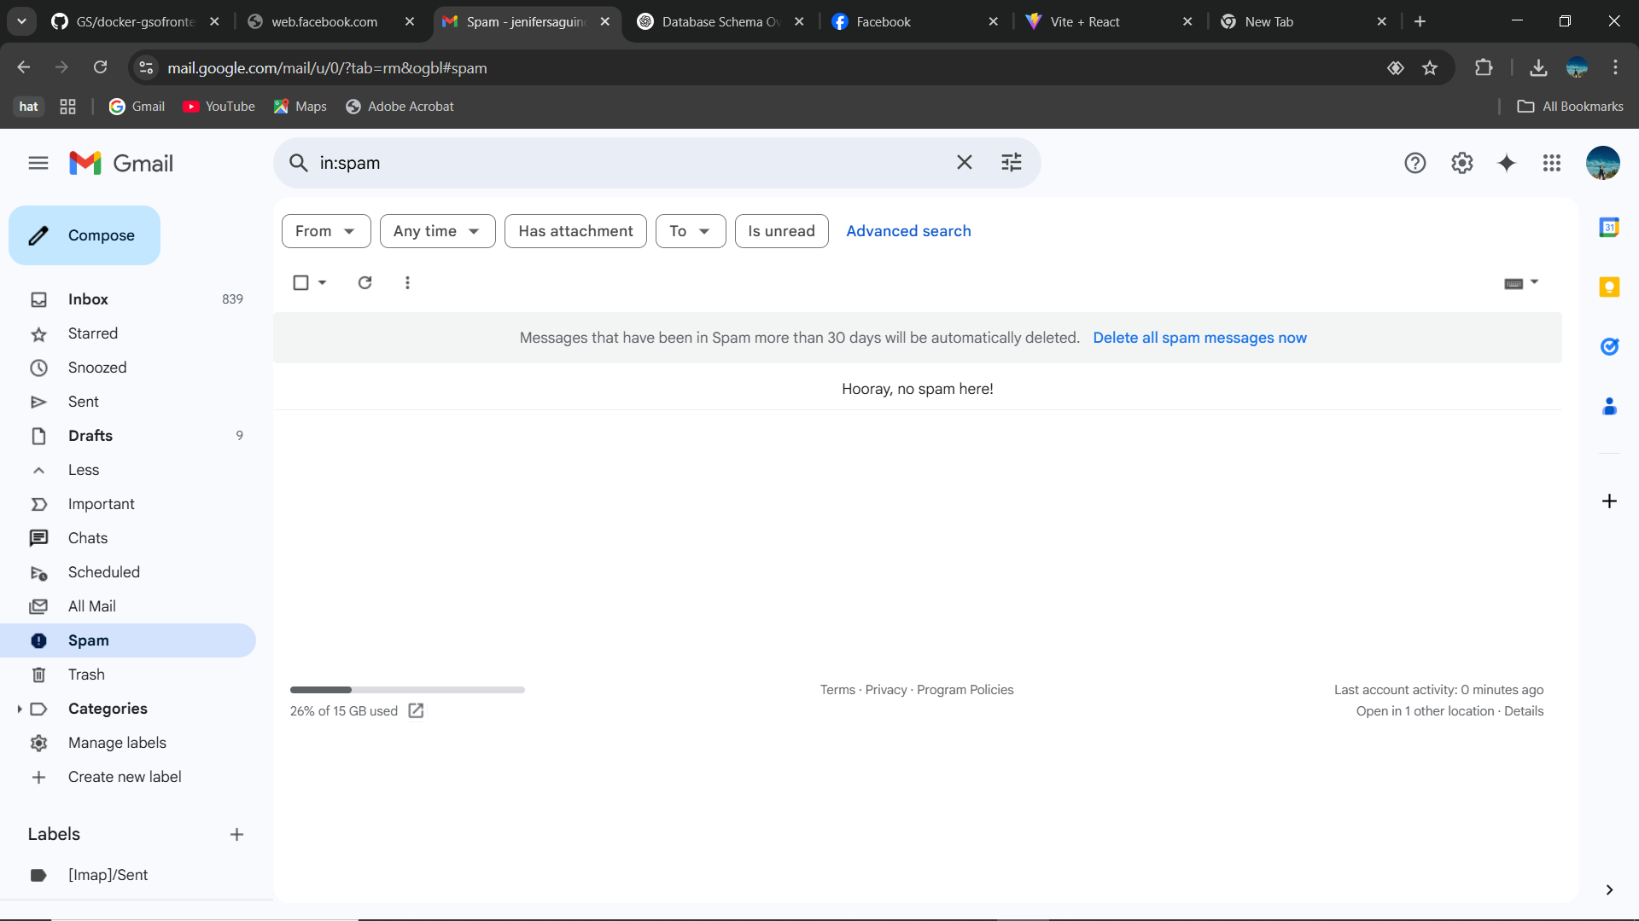
- Look if there is email sent from GSU, if there is, open the email.
- Then, click "Report not spam" to mark the email as legitimate and remove it from the spam folder.

